SIMATS ENGINEERING
ASSESSMENT TOOL 1
COURSE NAME: Database Management Systems
COURSE CODE: CSA05

COURSE OUTCOME COVERED

CO2: Apply the relational model, relational algebra, SQL query structures, and views to solve database querying and data manipulation problems. (BL3, BL6)

Activity Tool : Analytical Problem Solving (High)
Assessment Tool Weightage: 40%

QUESTIONS
Q.No | Question | Bloom's Level
1 | Given a set of relations and sample data, write SQL queries to retrieve specific information using joins and subqueries, and explain the logic used. Bloom’s Level: BL3 – Apply | BL4 – Analyze
2 | Using relational algebra, formulate expressions to solve complex queries such as retrieving records that satisfy multiple conditions across relations.  Bloom’s Level: BL4 – Analyse | BL5 – Evaluate
3 | Given a real-world scenario (e.g., banking or student system), design a relational schema and construct appropriate SQL queries for data retrieval and updates. Bloom’s Level: BL6 – Create | BL6 – Create
4 | Analyse a given SQL query with nested subqueries and predict its output, explaining each step of execution. Bloom’s Level: BL4 – Analyze | BL6 – Create
5 | Compare different SQL approaches (joins vs subqueries) for solving the same problem and evaluate their efficiency. Bloom’s Level: BL5 – Evaluate | BL4 – Analyze
6 | Design and implement views for a database system to provide restricted data access, and justify their use for security and abstraction.  Bloom’s Level: BL6 – Create | BL5 – Evaluate
7 | Given a database schema, write relational algebra expressions and convert them into equivalent SQL queries, analyzing differences in representation.  Bloom’s Level: BL4 – Analyze | BL4 – Analyze
8 | Optimize a set of inefficient SQL queries by restructuring them using joins, indexing concepts, or views, and evaluate performance improvements.  Bloom’s Level: BL5 – Evaluate | BL5 – Evaluate
9 | Develop a complex SQL query involving grouping, aggregation, and nested queries to solve a real-world problem.  Bloom’s Level: BL6 – Create | BL6 – Create
10 | Given multiple relations, analyze the query requirements and decide whether to use views, joins, or subqueries, justifying your choice with reasoning.  Bloom’s Level: BL5 – Evaluate | BL5 – Evaluate

Code of Conduct:

I ____________________ (Name / Reg No) certify that this submission is my original work and that I have adhered to the guidelines specified for this assessment.
I understand that any violation of academic integrity rules will result in disciplinary action.

Signature of the student:

RUBRICS FOR CALCULATION:

Criteria | Level 4 (Exemplary) | Level 3 (Proficient) | Level 2 (Developing) | Level 1 (Beginning)
Problem Understanding | Clearly interprets problem, identifies all parameters and requirements accurately | Understands problem with minor gaps | Partial understanding; misses key elements | Misinterprets or unable to understand problem
Method Selection | Selects most appropriate method/formula with strong justification | Selects correct method with minor errors | Inappropriate or partially correct method | Unable to select method
Solution Process | Logical, systematic steps with correct approach throughout | Mostly correct steps with minor mistakes | Disorganized steps; multiple errors | No clear process
Accuracy of Calculation | All calculations accurate; correct final answer | Minor calculation errors | Frequent errors; incorrect final answer | No valid calculations
Interpretation of Results | Clearly interprets results with units and engineering relevance | Basic interpretation with minor omissions | Limited or unclear interpretation | No interpretation

1. Given a set of relations and sample data, write SQL queries to retrieve specific information using joins and subqueries, and explain the logic used.

Department Table:

DeptID | DeptName
1 | CSE
2 | ECE
3 | IT
4 | MECH

Student Table:

StudentID | StudentName | DeptID | Age
101 | Rahul | 1 | 20
102 | Priya | 2 | 19
103 | Arjun | 1 | 21
104 | Neha | 3 | 20
105 | Karan | 4 | 22

Mark Table:

StudentID | Subject | Marks
101 | DBMS | 92
102 | DBMS | 78
103 | DBMS | 85
104 | DBMS | 88
105 | DBMS | 65

Join:

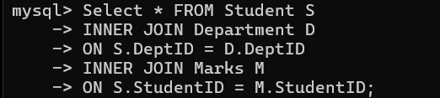

StudentID | StudentName | DeptName | Subject | Marks
101 | Rahul | CSE | DBMS | 92
102 | Priya | ECE | DBMS | 78
103 | Arjun | CSE | DBMS | 85
104 | Neha | IT | DBMS | 88
105 | Karan | MECH | DBMS | 65

Sub Query:

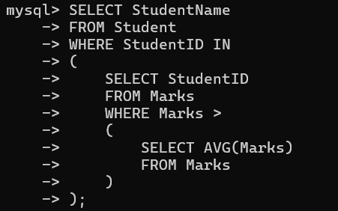
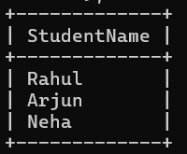

StudentName
Rahul
Neha

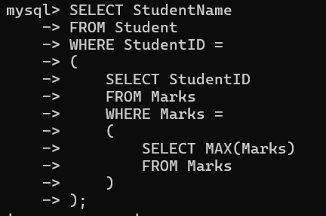
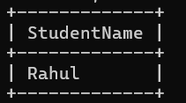

StudentName
Rahul

2. Using relational algebra, formulate expressions to solve complex queries such as retrieving records that satisfy multiple conditions across relations.

1. Students from the CSE department scoring more than 80 marks
πStudentName,Marks​(σDeptName=′CSE′∧Marks>80​((Student⋈Student.DeptID=Department.DeptID​Department)⋈Student.StudentID=Marks.StudentID​Marks))

StudentName | Marks
Rahul | 92
Arjun | 85

2. Students whose age is greater than 20 and marks are greater than 80

πStudentName,Age,Marks​(σAge>20∧Marks>80​(Student⋈Student.StudentID=Marks.StudentID​Marks))

StudentName | Age | Marks
Arjun | 21 | 85

3. Students belonging to the IT department

πStudentName​(σDeptName=′IT′​(Student⋈Student.DeptID=Department.DeptID​Department))

StudentName
Neha

3. Given a real-world scenario (e.g., banking or student system), design a relational schema and construct appropriate SQL queries for data retrieval and updates.

- Display all Students :

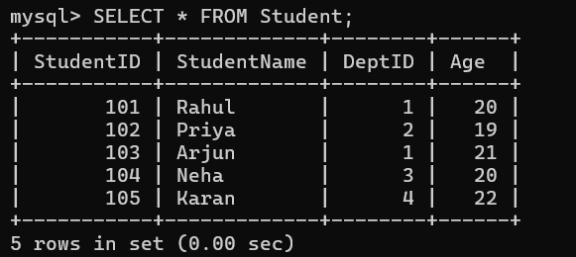

- Display Student name, Department and marks:

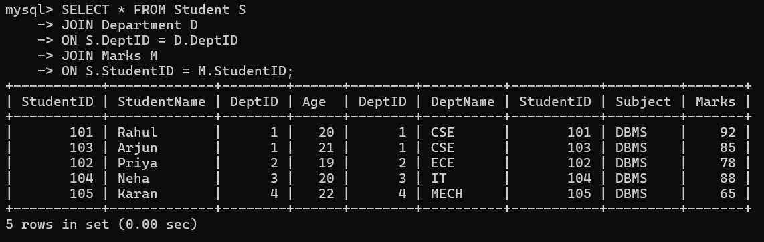

- Update Rahul’s marks:

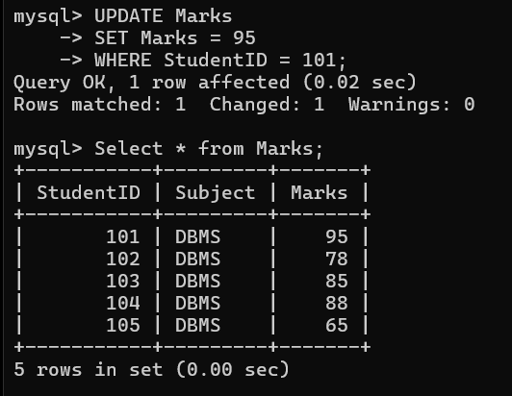

- Change Priya’s Department to IT:
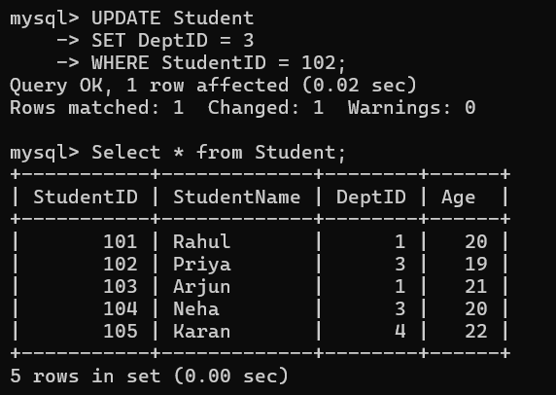

- Insert a new Student:
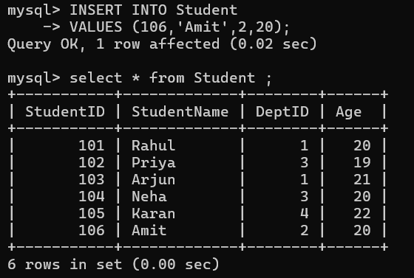

- Delete a Student:

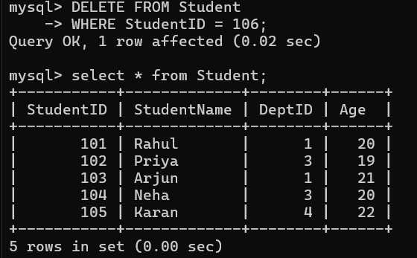

4. Analyse a given SQL query with nested subqueries and predict its output, explaining each step of execution.

SQL Query:

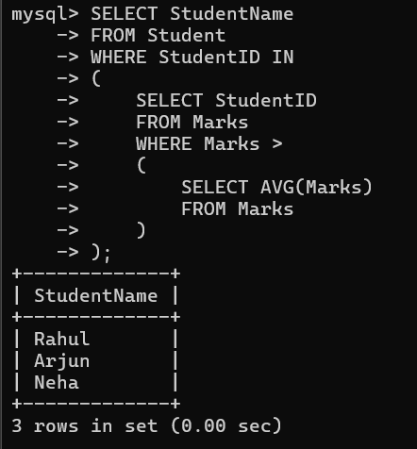

Innermost Query:

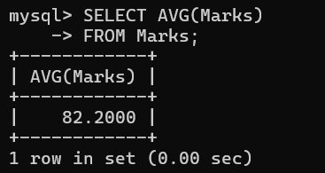

Middle Query:

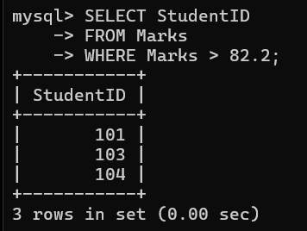

Outermost Query:

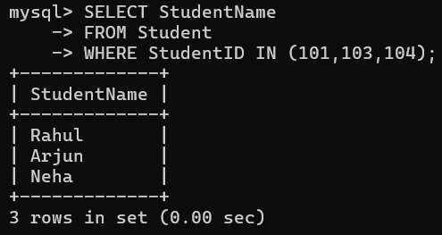

5. Compare different SQL approaches (joins vs subqueries) for solving the same problem and evaluate their efficiency.

Problem Statement
Display the names of students who scored more than 80 marks.

Approach 1: Using JOIN

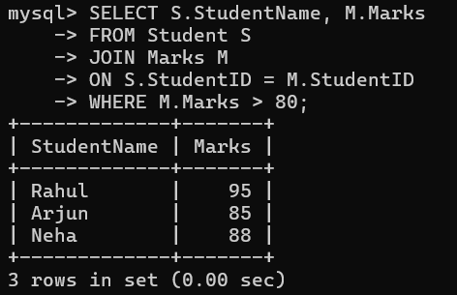

Approach 2: Using Subquery

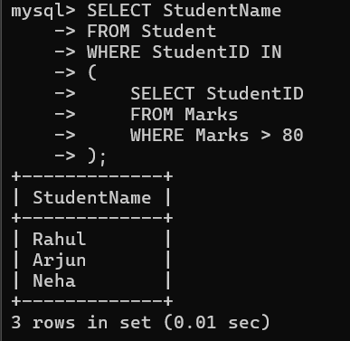

Criteria | JOIN | Subquery
Performance | Faster for large datasets | Slightly slower due to nested query execution
Readability | Better when retrieving data from multiple tables | Simpler for filtering based on another query
Data Retrieval | Retrieves columns from multiple tables | Mainly used to filter rows
Efficiency | More efficient and optimized by the DBMS | Less efficient for complex nested queries

Evaluation
- JOIN is generally more efficient because it directly combines related tables and is optimized by most database systems.
- Subqueries are useful when the result of one query is needed as input to another, making them easier to understand for some filtering tasks.
- For retrieving data from multiple tables, JOIN is the preferred approach.
- For simple filtering based on another query's result, a subquery is a good choice.

6. Design and implement views for a database system to provide restricted data access, and justify their use for security and abstraction

Student Details view:

This view displays only the student's name, department, and marks without exposing Age or DeptID.
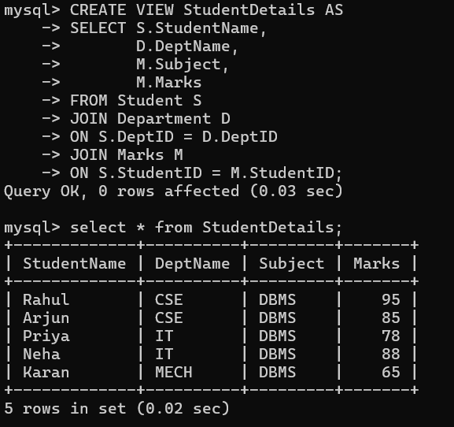

Displaying Only the High scorers:

This view shows only students who scored more than 80 marks.

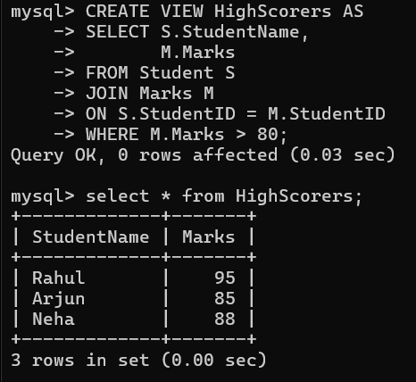

Justification
Security
- Views restrict access to sensitive data such as Age and DeptID.
- Users can access only the information they are authorized to see.
Abstraction
- Views hide the complexity of SQL joins.
- Users can retrieve data from a single virtual table instead of querying multiple tables.

7. Given a database schema, write relational algebra expressions and convert them into equivalent SQL queries, analysing differences in representation

Display Student Name, Department, and Marks

1.Relational Algebra:

π StudentName, DeptName, Marks
(
(Student ⋈ Student.DeptID = Department.DeptID Department)
⋈ Student.StudentID = Marks.StudentID Marks
)

StudentName | DeptName | Marks
Rahul | CSE | 95
Priya | IT | 78
Arjun | CSE | 85
Neha | IT | 88
Karan | MECH | 65

2.SQL Query:

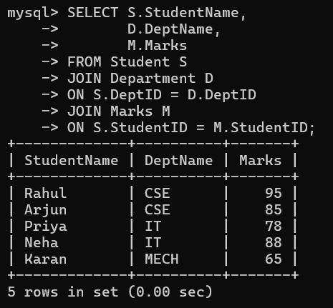

Relational algebra | Sql
Uses mathematical operators (π, σ, ⋈) | Uses sql keywords (select, from, where, join)
Describes the logical operations to retrieve data | Specifies the actual query syntax executed by the dbms
Mainly used for query design and optimization | Used to retrieve and manipulate data in databases
Not directly executable | Executable in any sql-supported dbms

Conclusion
- Relational algebra provides the theoretical foundation for database queries using mathematical operators.
- Sql is the practical implementation of those operations and is used to interact with relational databases.
- Both represent the same logic, but sql is the language executed by the database system.

8. Optimize a set of inefficient SQL queries by restructuring them using joins, indexing concepts, or views, and evaluate performance improvements.

Query 1:
Using Sub Query:

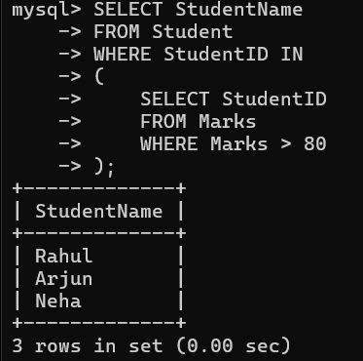

Using Join:

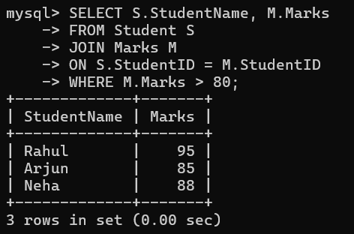

Query 2:

Without Index:

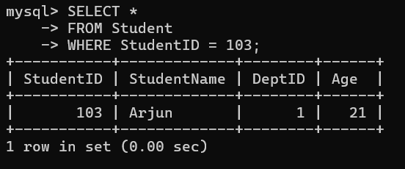

With Index:
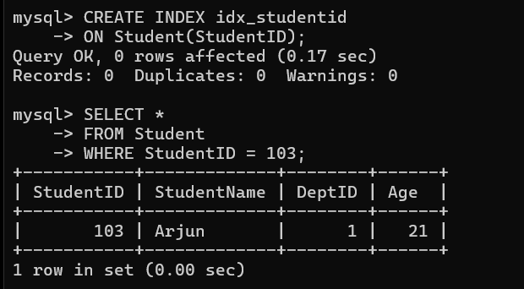

Query 3:

Repeated Join Query:

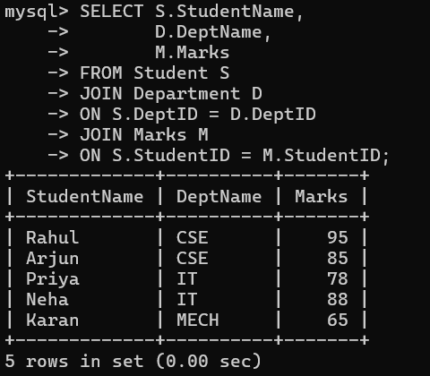

Optimized using a view:

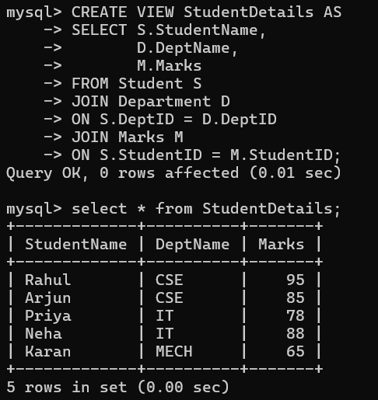

Optimization Technique | Benefit
JOIN instead of Subquery | Faster execution and better optimization
Indexing | Speeds up data retrieval by reducing table scans
Views | Simplifies complex queries and improves maintainability

Conclusion
By replacing nested subqueries with JOINs, creating indexes on frequently searched columns, and using views for repeated complex queries, SQL performance and readability are significantly improved. These techniques reduce query execution time and make database operations more efficient.

9. Develop a complex SQL query involving grouping, aggregation, and nested queries to solve a real-world problem.

Problem Statement
Display the departments whose average marks are greater than the overall average marks.

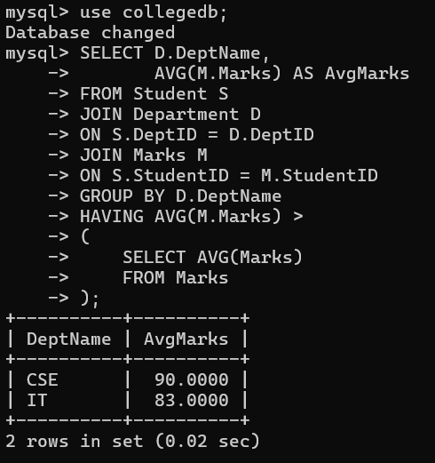

10. Given multiple relations, analyze the query requirements and decide whether to use views, joins, or subqueries, justifying your choice with reasoning.

Requirement 1: Display Student Name, Department, and Marks
Best Choice: JOIN

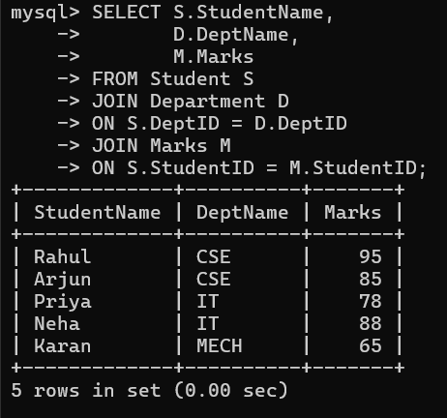

Requirement 2: Find Students Scoring Above the Average Marks
Best Choice: Subquery

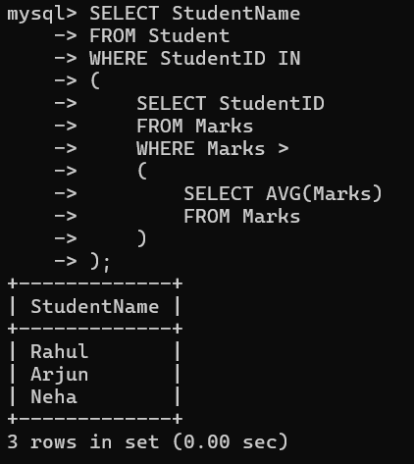

Requirement 3: Frequently Display Student Name, Department, and Marks
Best Choice: View

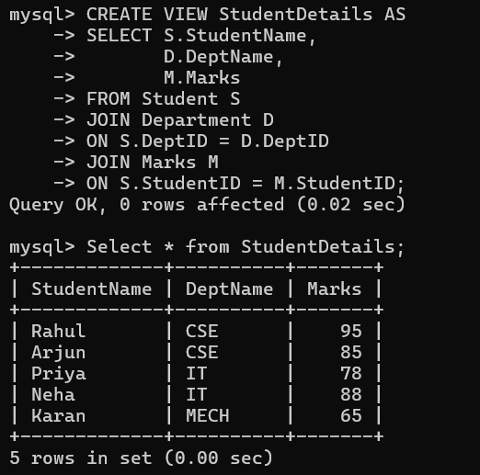
Requirement | Best Option | Justification
Retrieve data from multiple tables | JOIN | Efficiently combines related tables
Filter records based on another query | Subquery | Uses the result of one query inside another
Reuse the same complex query repeatedly | View | Simplifies access and provides abstraction

Conclusion
- JOIN is best for combining related tables.
- Subquery is best when a query depends on the result of another query.
- View is best for repeated access to the same data and for providing security and abstraction.
The choice between JOIN, Subquery, and View depends on the query requirement, with each approach offering specific advantages for different database operations.

